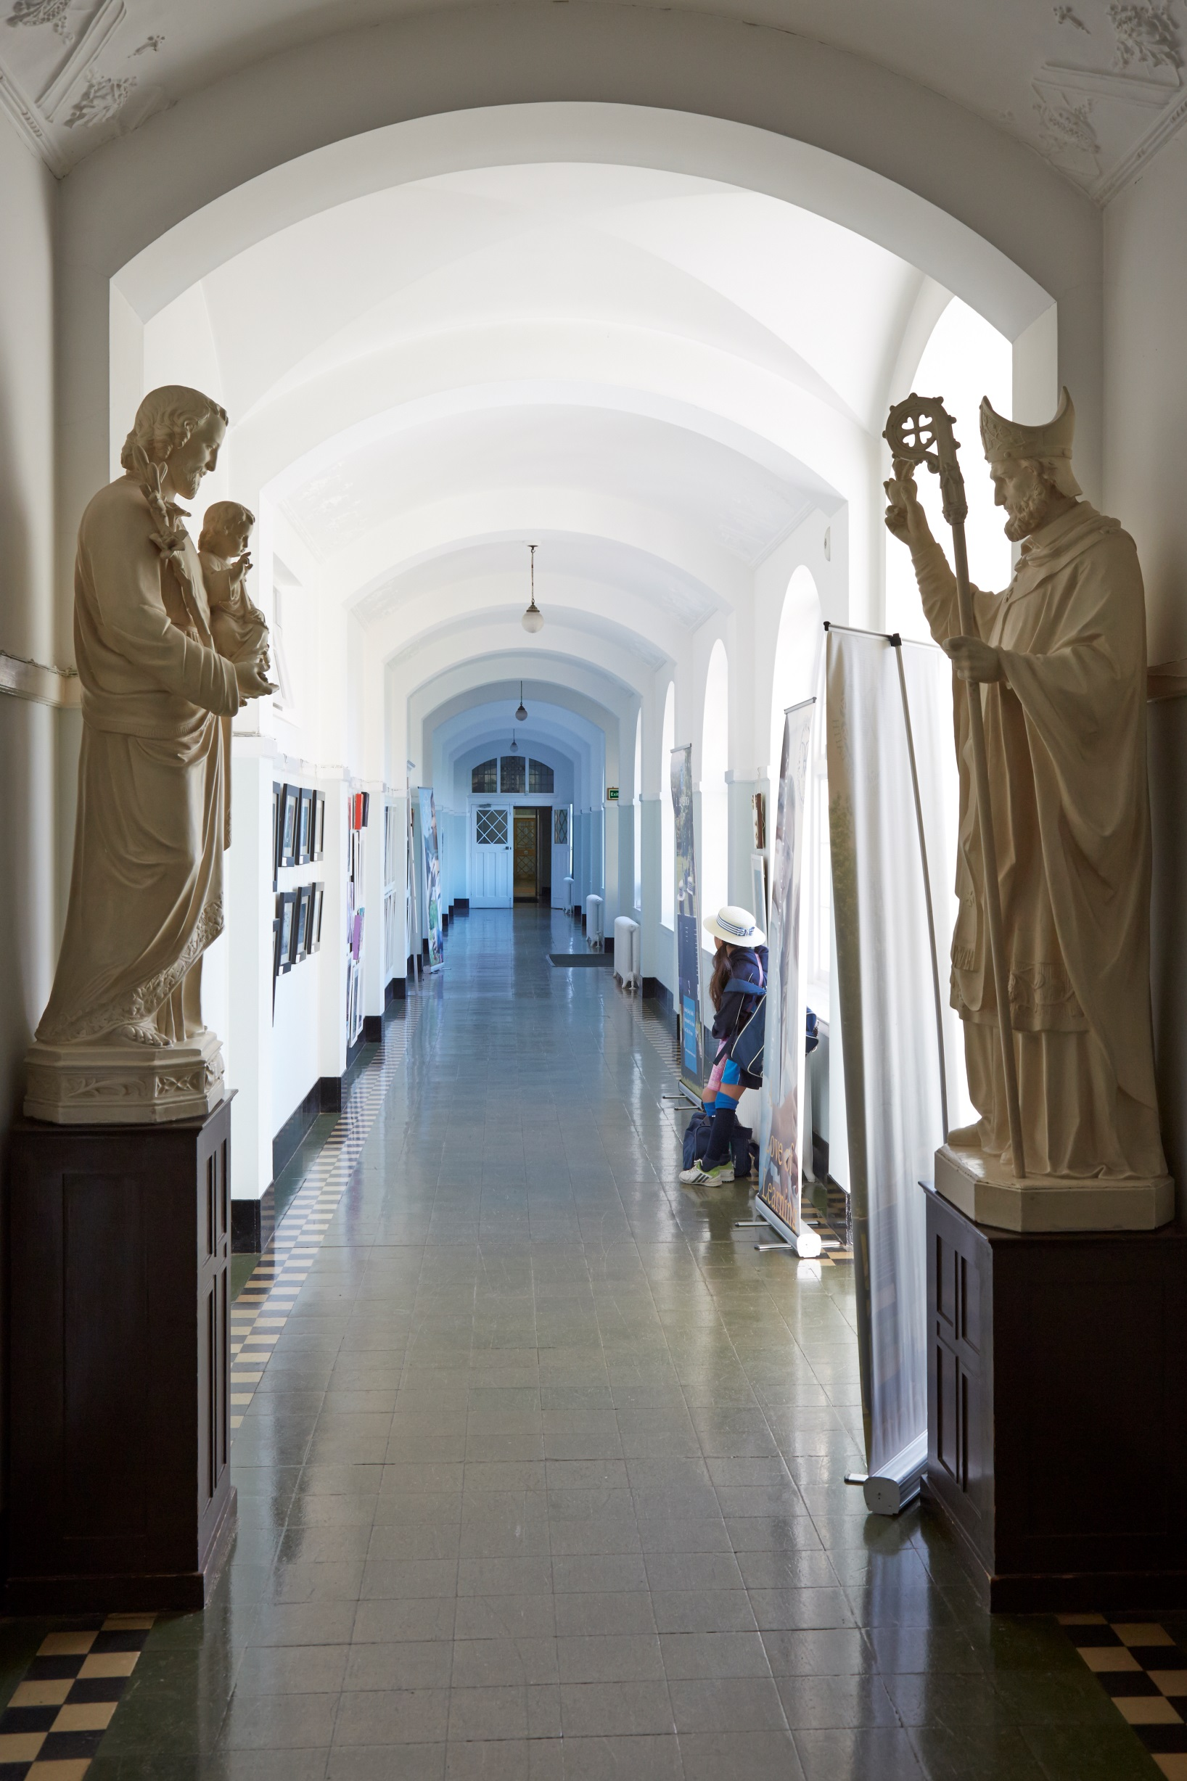
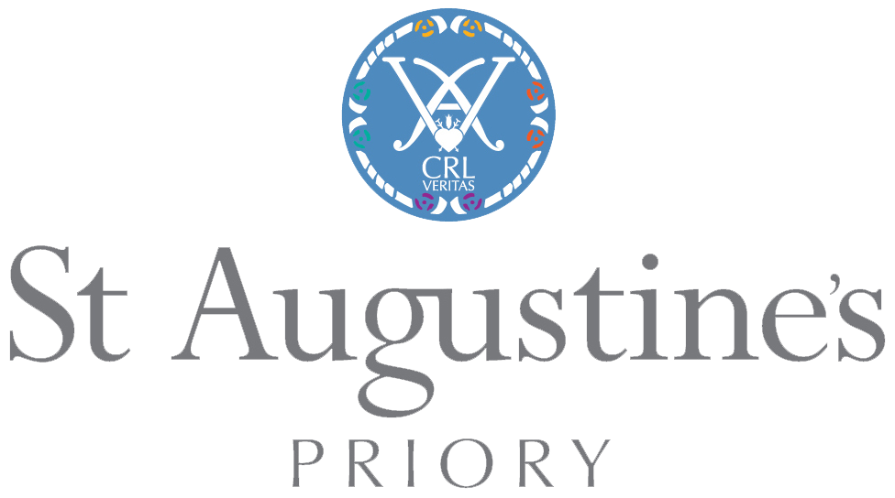

GCSE Information Booklet

2015 -16

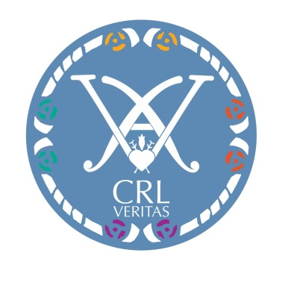
Pathways Programme

Beyond Upper IV …
2014-15
… A Guide to Your GCSE Choices
CONTENTS

 |  | Page
GCSE: Making the Right Choices …………………………………………. |  | 3
CORE SUBJECTS ……………………………………………………………. |  | 5
 | GCSEs at a Glance | 6
 | Religious Studies | 7
 | English Literature | 8
 | English | 9
 | Mathematics | 10
 | Science | 11
GCSE OPTIONS ……………………………………………………………. |  | 14
 | Art and Design | 15
 | Astronomy…………………………… | 16
 | Classical Civilisation | 17
 | Classical Greek | 18
 | Computing…………………………... | 19
 | Drama | 20
 | French | 21
 | Geography | 23
 | History | 24
 | Information Communication & Technology…………………………. | 25
 | Latin | 26
 | Music | 27
 | Physical Education | 28
 | Russian | 29
 | Spanish | 31
And Then…? ………………………………………………………………… |  | 33
Didn’t they do well …………………………………………………………. |  | 34
My Notes ……………………………………………………………………… |  | 35

GCSE: Making the Right Choices

Making the right choice of subjects for GCSE is very important. It is your first step towards the world of careers and work. You need to read this booklet and think about it carefully, then get advice from your teachers and discuss your ideas at home.
Why is choosing the right GCSEs important??

Some of you will already have a clear idea of what you would like to do later in life, but most of you will not. Throughout your Upper IVth year at St Augustine’s Priory, as part of our Pathways Programme, you will attend various events such as Careers Day and Insight into Industry Day which are all designed to help you make the right choices. You do not need to be sure what you want to do yet, but you can start to think about different types of careers and narrow them down to certain areas that may suit you.

GCSE stands for General Certificate of Secondary Education. The important word here is ‘General’. The aim of these courses is to give you a good solid understanding of the subjects you study and to give you something to build on for the future when you are in the Sixth Form and then at University. They are the beginning of your educational journey towards being an independent adult, earning your own living, contributing to society and developing as a person. It is important to remember that what you do now can affect your future.
What are GCSEs?

When you choose GCSEs you need to think about two factors. First of all yourself now, your skills, talents, interests and ambitions, and secondly, the skills you might need in the future in your career. This is why it is important to have a balanced combination of subjects which will provide you with a wide range of skills and knowledge. For example, you may think you would like to be a doctor; so it makes sense for you to aim towards the Triple Award Science International General Certificate of Secondary Education (IGCSE). But if you think about the work doctors do, it is not all scientific. They need to be able to deal with people effectively, they need to be able to draw clear conclusions from what they read, and they need to be sensitive and caring. And so you can see that there are things to be learnt from subjects like History, Art, Drama and English Literature for example, that could also be important in helping patients. The same is true for almost any profession. Just talk to your parents about all the skills they have developed to enable them to be able to do their work. Remember, the key to all this is knowing yourself well and being realistic.
How do I decide which subjects to do?

What makes a good balance?
In addition to Religious Studies, English Language and Literature, Mathematics and Science you should do at least one language, one humanities and one arts subject; then you should choose the remaining subject based on your interests and skills. Most girls will do the five core subjects (including Double or occasionally Single Award Science) and four options, but if it is felt that the Triple Science pathway is appropriate for you, then you will only take an additional three options (see GCSEs at a Glance document).

How should I use this booklet?
This booklet gives you information about each subject. It will tell you what the course involves, how many parts there are to the exam and what controlled assessment (for which preparation and the task are performed under exam conditions) is involved. It will also tell you some of the other skills you can develop through learning that particular subject. Now read on….

As you will already know, new specifications for GCSEs are being introduced; as well as a new 1-9 grading system. The new GCSEs will be graded 1 to 9, with 9 being the top grade.
New specifications and 1-9 grading
The first subjects changing over to the new system are English Language, English Literature and Mathematics whose new courses have started this year and the first examinations for these courses will take place during the summer of 2017. All other subjects will be moving to new specifications in September 2016 with first examinations being taken in 2018. Your daughters will therefore be sitting the first round of these new GCSEs.
Please note that as well as following AQA, Edexcel and OCR examination boards, some departments choose to teach the International GCSE (IGCSE) such as Science and Modern Foreign Languages. More information on these can be found on the subject pages of this booklet.

Core Subjects
You will all study:
English Language
Maths
Science
English Literature
Religious Studies

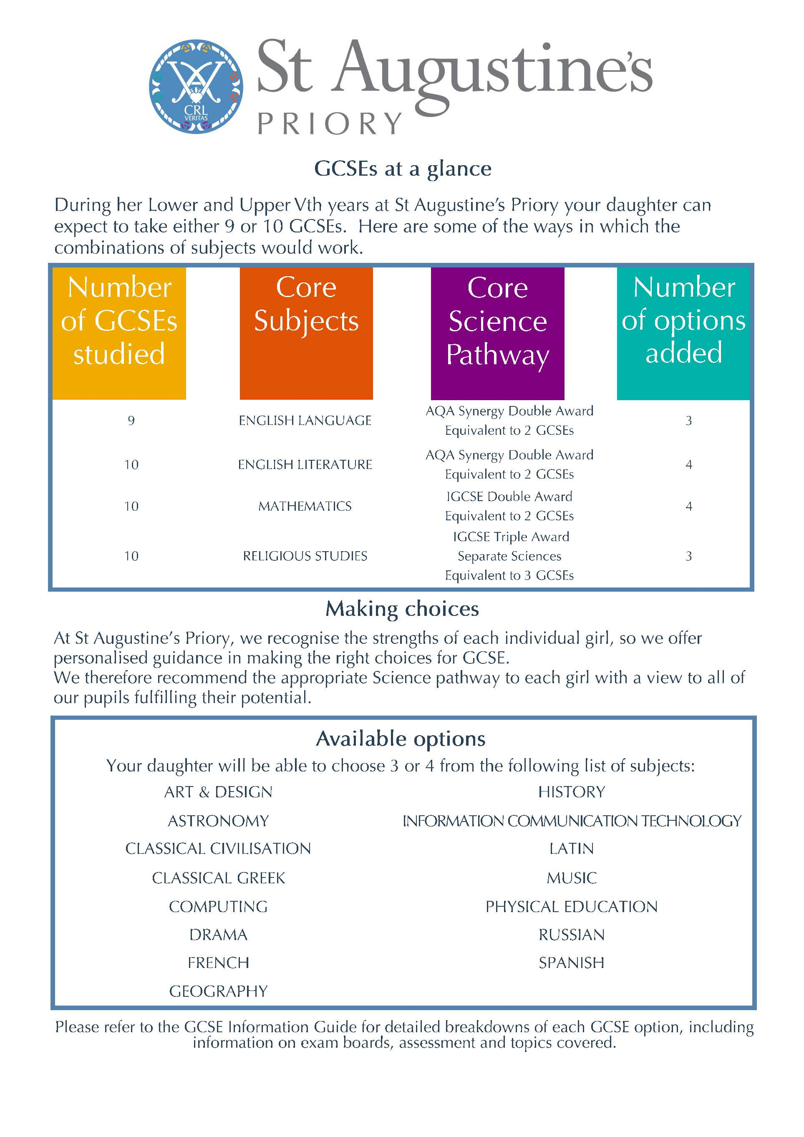
Religious Studies
Important note At the time of going to press, the new specifications for first teaching in 2016 are still in draft form and have yet to be approved by Ofqual (Office of Qualifications and Examinations Regulation.) It is hoped the final specifications will be published by December 2015.
The details outlined below are based on the DfE (Department for Education) and Ofqual criteria for the new GCSE in Religious Studies.

Why Religious Studies?

By studying Religious Studies you can develop your interest in, and enthusiasm for, the study of religion, and relate it to the wider world. You will be given the opportunity to explore Christian beliefs and reflect on fundamental questions, intellectually and personally. You will be able to reflect on and develop your own values, opinions and attitudes in light of your learning.

Why is it useful? Religious Studies offers students the opportunity to develop their spiritual and moral education. It also enhances their personal, social and cultural development. The subject gives them the opportunity to think about the impact religion has on all aspects of life today and gives them the tools to ask questions about their own understanding of the world.

How am I assessed?
The new GCSE will be linear, this means that all exams will be sat at the end of Upper V. As yet we do not know the length of the exams or how many. However, it is thought there will be two separate papers lasting either 1 hour 45 mins or 2 hours. Again, this will be decided once the specifications have been approved.

When will I be assessed?
At the end of Upper V.

Which syllabus is it?
Currently we follow the Edexcel Religious Studies Long course 2RS01.
It has yet to be decided which specification we will follow. As a Catholic School, we will be advised by the Bishops’ Conference when making that decision.

The new new overall subject content will be divided into two parts:
Part 1: Study of Religions – we will study Catholic Christianity and one other religion.
Part 2: Thematic studies – this will be based on textual studies and/or Religious, philosophical and ethical studies in the modern world

What other skills will I develop?
Religious Studies will give you the opportunity to develop your own sense of curiosity and enquiry. You will be able to express your own opinions on many moral issues and also consider other people’s points of view so your listening and speaking skills will improve.

And then…?
Students who take Religious Studies can go on to a wide range of careers including Education, Law, Journalism, Marketing, Advertising and Human Resources.

English
Overview

Commencing in September 2015, we will be teaching the new AQA English Language and English Literature specifications. These are engaging courses which strike a model balance between academic rigour and creativity. Both are full two year courses with all exam-based assessments to be sat in June 2018.

These two courses complement each other well, providing you with a broad range of transferable skills, and a strong foundation on which to build in KS5. Each course has a distinct focus, which is detailed below.

Literature: Structure

Paper 1
Study
- Two texts: One Shakespeare play and one 19th-century novel.
(Example texts: Shakespeare’s Macbeth, Charlotte Brontë’s Jane Eyre, Jane Austen’s Pride & Prejudice)
Assessment
- Written exam: 1 hour 45 minutes
- Closed book
- 40% of GCSE (64 marks)
+
Paper 2
Study
- Modern texts: One drama and one prose
(Example texts: J. B. Priestley’s An Inspector Calls, William Golding’s Lord of the Flies)
- Poetry: One anthology cluster will be studied, with focus on a particular theme.
(Example themes: Love & Relationships, Power & Conflict.)
- Unseen poetry: Note that students should be reading widely with a focus on analysis. You are
expected to read beyond the text to gain an understanding of context.
Assessment
- Written exam: 2 hours 15 minutes
- Closed book
- 60% of GCSE (96 marks)

Aims and Learning Outcomes

In addition to advances in your subject knowledge and skills in reading and writing, this course is designed to develop your critical thinking and evaluative skills. Discussion of your understanding and ideas will help you to appreciate the depth and power of English literary heritage. You will use an increasingly wide vocabulary, including the grammatical terminology and other literary and linguistic terms needed to analyse effectively.

Language: Structure

Note: All texts in the English Language examinations will be unseen.
Paper 1: Explorations in Creative Reading and Writing
What’s assessed
- Section A - Reading: One literature fiction text
- Section B - Writing: Descriptive or narrative writing
Assessment details
- Written exam: 1 hour 45 minutes
- 50% of GCSE (80 marks)
+
Paper 2: Writers’ Viewpoints and Perspectives
What’s assessed
- Section A - Reading: One non-fiction text and one literary non-fiction text
- Section B - Writing: Writing to present a viewpoint
Assessment details
- Written exam: 1 hour 45 minutes
- 50% of GCSE (80 marks)
+
Non-Exam Assessment: Spoken Language
What’s assessed
- Presenting
- Responding to questions and feedback
- Use of Standard English
Assessment details
- Teacher set throughout course
- Marked by teacher
- Although this unit carries 0% weighting, it is compulsory and is acknowledged by certification.

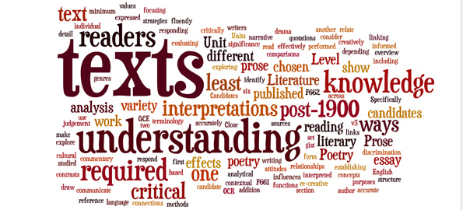
Mathematics
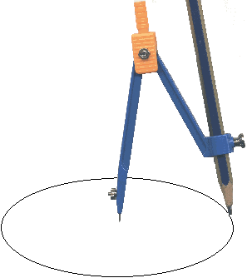

What the course involves:
You will learn more about number, algebra, geometry, trigonometry and data handling. You will learn to use your mathematical knowledge in a variety of situations and will be expected to solve problems with or without a calculator. You will use the same textbook throughout Lower V and Upper V, as it covers most of the GCSE syllabus and also enables you to revisit topics you met in earlier years. You will also be using worksheets, help sheets and past exam papers.

Exam Board: Edexcel
Syllabus: 1MA1 (Linear)
All the Exam boards have a two-tier structure for the Mathematics GCSE: Foundation and Higher.
The girls will be taught in three sets and the final decision about the tier of entry for each girl will be made after the mock exams during the Upper V year.
We expect the vast majority of girls to sit the Higher Level exam.
Scheme of Assessment
Written Exams | Weighting | Foundation | Higher
Paper 1 (Non-calculator) | 33⅓% | 1 hour 30 minutes | 1 hour 30 minutes
Paper 2 (Calculator) | 33⅓% | 1 hour 30 minutes | 1 hour 30 minutes
Paper 3 (Calculator) | 33⅓% | 1 hour 30 minutes | 1 hour 30 minutes

Grade Structure
 | Foundation | Higher
Grades | 5 - 1 | 9 - 4

Comparison (old grades and new grades):
New Grade (Higher) | 9 | 8 | 7 | 6 | 5 | 4
New Grade (Foundation) |  |  |  |  | 5 | 4 | 3 | 2 | 1
Old Grade | A*/A | A*/A | B | B | C | C | D | E | E
Text book used: White: Higher GCSE Maths (Elmwood)

Why the subject is useful:

“Mathematics is the language with which God has written the universe”

Galileo Galilei
We use maths every day though often we do not realise it. It is all around us and a good understanding of it will help in our daily lives. It is not only useful but essential for the obvious things like helping us to manage our money and deal effectively with many other everyday calculations involving, for instance, time, distance, proportions and percentages. The clearest way of presenting information is by tabulating results and using appropriate graphs - of which there are many types - to display them. We are surrounded by mathematics and often use it without being aware of it. We see it in art, in the patterns that appear in nature, in music and rhythm. Technological progress would have been impossible without the involvement of mathematics.

Careers possibilities:
GCSE Mathematics is a core subject and is a fundamental requirement in the vast majority of careers and in higher education.
Studied beyond GCSE, Mathematics opens the door to a huge range of career opportunities.

Science (Edexcel and AQA)

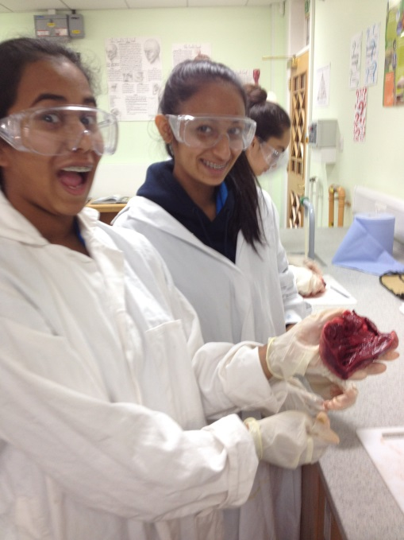
Biology | Chemistry | Physics

“Most people say that it is the intellect which makes a great scientist. They are wrong: it is character.”
Albert Einstein

Why Science?
An understanding of Science allows you to have informed opinions about many important and controversial issues, such as designer babies, the effect humans are having on the planet and its organisms, and the structure of the universe and the particles of which it is composed.
Science Pathways:

- Science is a core subject, this means that everyone will do all 3 Sciences to GCSE level.
- The Science Department offers Triple Science as an option choice.
- It is expected that the majority of the year will follow the Double award pathway.
- For those who find Science challenging the Department also offers the AQA Synergy Double Award scheme.
- Apart from your normal in-class tests you will also sit 2 examinations that will determine the pathway that you follow. These will be in January and May in your Upper IV year.
- After the January examination you will receive a letter that will either offer you the choice of taking Triple Science as an option or say that you will follow the Double Award pathway or the AQA Double Award Synergy pathway.
- If you decide to accept the Triple option, then it takes up one of your option choices.
- Your progress will then be monitored over the next few months.
- After the May examination the final choice will be made about the Science pathway that you will follow.

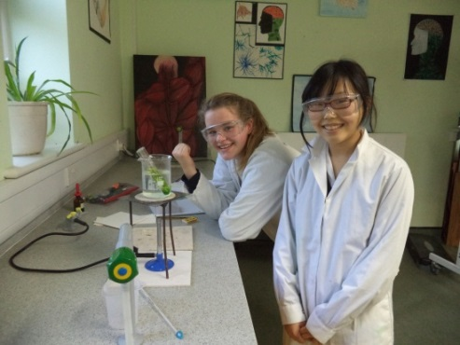
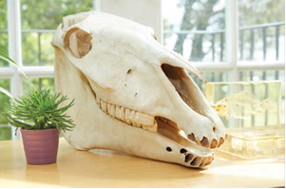
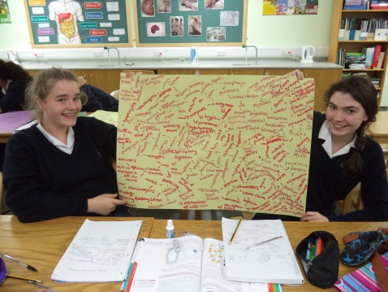

How am I assessed?

Edexcel International GCSE
- Double Award:

Three 2 hour papers
Biology Paper 1  33.3% | + | Chemistry Paper 1  33.3% | + | Physics Paper 1  33.3% |  | Science IGCSE  (2 Grades)

- Triple Award:

Three 2 hour papers
Biology Paper 1  66.6% | Chemistry Paper 1  66.6% | Physics Paper 1  66.6%
+ | + | +
Three 1 hour papers
Biology Paper 2  33.3% | Chemistry Paper 2  33.3% | Physics Paper 2  33.3%
Biology IGCSE | Chemistry IGCSE | Physics IGCSE

AQA Synergy
- Double Award
4 1hour 45 minute examinations
Paper 1 (25%) Topics 1-4 | Paper 2 (25%) Topics 1-4 | Paper 3 (25%) Topics 5-8 | Paper 4 (25%) Topics 5-8

About the course:

- When will I be assessed?
For the IGCSE all assessments will be held at the end of the course in the summer term of
Upper V. There is no controlled assessment.

- Which syllabus is it?
Edexcel IGCSE
All specifications can be accessed from
http://www.edexcel.com/quals/igcse/int-gcse11/Pages/default.aspx

What other skills will I develop?

You will develop your practical skills throughout the course. As you progress you will learn how to acquire, present and evaluate information, and you will understand how scientists use controlled experiments to arrive at conclusions.

And then…?

Many careers require you to have at least one Science GCSE at grade C or above.
The IGCSE gives an excellent grounding for progression to any, or all, of the A Level Sciences, essential for those considering medical or related careers.

The Triple Award Science is an option; if you choose to take it then it will take up one of your option blocks. If you do really well in the January examinations then you will be offered the chance of taking the Triple Award pathway.

If you choose Triple Award then your progress will be closely monitored over the course of the year and your performance in the Summer examinations will be taken into consideration as well. This is because it is your teachers have the final say in whether or not you are able to start the Triple course. If we feel that it is not the right choice for you then you will have to pick another option from the same block as Triple Science.

The majority of the year will be sitting the Double Award papers. However, if you have found Science very challenging then we will recommend that you follow the AQA Single Science Pathway. This leads to one GCSE in Science. The Single Science Course is an accredited GCSE and is recognised by universities. If you do sit the Single Science paper then this will not allow you to take Science A Levels.

GCSE OPTIONS
Most students choose four of these subjects.
Make sure you have a balance of subjects
so that you keep your options open for the future.
For example, a good idea might be to start by choosing:

One extra arts or humanities subject
One arts subject
One humanities subject
One language

Art and Design
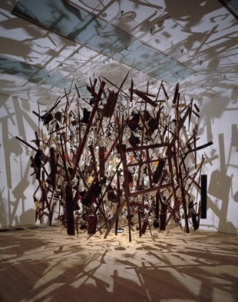
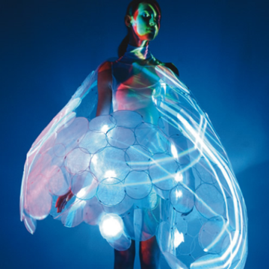
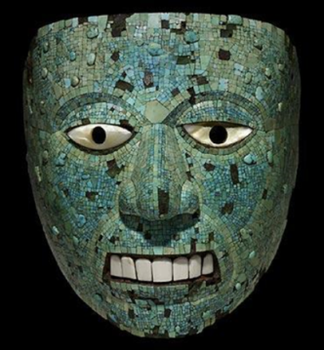

Why Art and Design? If you love creating and working with your hands this is a course for you. It is mostly a practical course; however, you will also be required to critique your own and others’ artwork in written form. You will develop a wide range of skills involving drawing, painting, printmaking, sculpture, textiles and digital media and apply these to the development of exciting and unique artwork. To complement this, you will explore your own visual culture and look to the expertise of artists from the past, present and other cultures. You will keep a series of sketchbooks and initially work on set topics, but in time will develop independence in your art practice.

Why is it useful? If you want to pursue a career in Art and Design, this is a necessary subject for you. The creative industries are the fastest growing industries in the UK at present. Whether you are pursuing freelance work or working as part of an organization, developing creativity and skill is essential. Working with your hands is a valuable skill to have, not only if you want to pursue a career in Art and Design but also in terms of your practical engagement with the world around you. Studying Art allows you to interpret the world and ‘think outside the box’.

How am I assessed? Unit 1 Personal Portfolio (Coursework) = 60% of final mark
Unit 2 (Exam) = 40% of final mark

When will I be assessed? Art GCSE is assessed at the end of Upper V. Units 1 and 2 will be assessed internally by your teachers and then externally by a visiting Edexcel moderator. Unit 1 comprises two coursework projects completed during your Lower V year and up until January of Upper V. Unit 2 begins with the exam paper being released to you in February and culminates in a 10 hour, 2 day timed examination in May. All work produced throughout the course will be formatively assessed by your teacher with targets set to develop and refine your coursework and exam submissions.

Which syllabus is it?
Edexcel Art and Design (Unendorsed) (www.edexcel.org)

What skills will I develop?
- creative and imaginative skills,
- practical skills for communicating & expressing ideas and feelings,
- aesthetic and critical skills,
- investigative, analytical, experimental and interpretive capabilities,
- an understanding of codes, conventions and contexts,
- a knowledge and understanding of art in society past and present.

*A visit to a major London gallery and exhibition is arranged for all GCSE Art Students and students are encouraged to independently attend exhibitions throughout the course.
*An Art Contribution of £65 per student per year is requested to enable us to supply high quality resources and an art pack for each student.

And then…?
Artists and designers play an important role in formulating our personal taste and leading the trends in many areas including fashion, photography, interior design, graphics, jewellery, theatre and film design, architecture, 3D and industrial design. There are career opportunities relating to art history in museums and galleries plus opportunities in education, conservation and restoration. Some students decide to link an interest in Art and Design with business and opt for careers such as merchandising.

Astronomy

Why Astronomy?
If the night sky holds a certain fascination for you, or you’re curious about the difference between a red giant and white dwarf, a pulsar and quasar, or what a super massive black hole truly is, then this course can help you take the first steps towards truly understanding and appreciating our universe. You can find out where you come from, and explain how we are all made of star dust.

Why is it useful? The astronomy course backs up parts of the GCSE physics course (the big bang theory, Doppler effect, electromagnetic spectrum, red shift). This course will develop your curiosity for astronomy, help you understand current astronomical theories and enhance your science studies and learn about different aspects of science, alongside your other science studies.

How am I assessed?
The GCSE in astronomy comprises two units:

Unit 1 Understanding the Universe  (2 hour exam - 75% exam) | Unit 2 Exploring the Universe  (broken into two projects - 25 %)
Covering the following topics:  - Earth, Moon and Sun  - Planetary Systems  - Stars  - Galaxies and Cosmology | Observing the night sky  - Unaided – by eye  - Aided – binoculars, telescope/robotic telescope

When will I be assessed?
One Theory Paper – Summer Term Upper V.
The controlled assessment will be broken up between one project in Lower V and one in Upper V, and will be submitted in the summer term of Upper V.

What other skills will I develop?
You will learn to interpret data in the form of graphs, numbers and diagrams. You will be introduced to planetarium computer programs, and exposed to a fast array of further information, developing your research skills. Discussion and debate are developed. Alongside this, you will develop practical skills in observing, using simple tools for investigations and designing observation based on identified criteria.

And then…?
This is a stepping stone to further education in Physics and Astronomy. Most of this context is featured in the astrophysics option of AQA A-Level Physics, and in Astrophysics in University. A degree in Physics or astrophysics can lead to numerous careers, including meteorology, aerospace engineering, designing satellites, working for an observatory/space agency.

Classical Civilisation
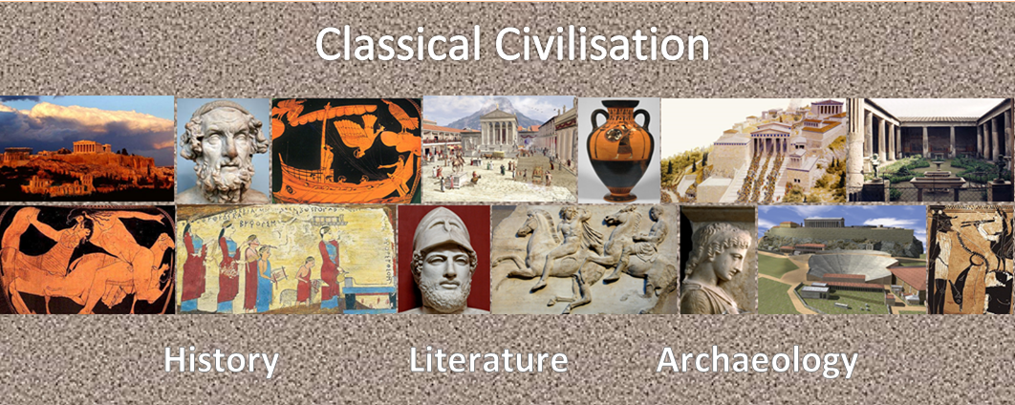
Why Classical Civilisation?
You can study Classical Civilisation at GCSE even if you have not done so in Upper IV; all are welcome!
In this wonderful subject you will study the history, literature and archaeology of two great civilisations that helped shape our own society. Recent GCSE students have read a tragedy by Sophocles, Greco-Roman myths by Ovid and Homer’s epic tale about Odysseus. They have studied the architecture of Roman Pompeii, the cultural life of classical Athens as well as investigating the site of ancient Olympia and its athletic contests. Classical Civilisation is a subject that is as broad as it is interesting.

Why is it useful?

This course is perfect for students interested in English, Drama, History, Politics and Archaeology. It adds a huge dimension to the understanding of literature, as our idea of what stories, plays and poems should be like comes from Greece and Rome. This also goes for politics, democracy and law. The literature we read is stimulating, and the cultural topics fascinating.

How am I assessed?

Unit A351: City Life in the Classical World (written exam) 25%
Unit A352: Epic and Myth (written exam) 25%
Unit A353: Community Life in the Classical World (written exam) 25%
Unit A354: Culture and Society (controlled assessment) 25%

When will I be assessed?

Classical Civilisation is a modular course and candidates take exams in three modules at the end of Upper V. There is also a controlled assessment module which is taken in the second year of the GCSE.

Which syllabus will I follow?

OCR

What other skills will I develop?

Classical Civilisation is an interesting subject, and by studying two societies different and yet close to our own you will learn to question and assess your own values and those of the society around you.

And then…?
You may continue with this subject all the way to university. Others use Classical Civilisation as an entrée into English, Drama, Politics, Economics, History and Archaeology.

Classical Greek

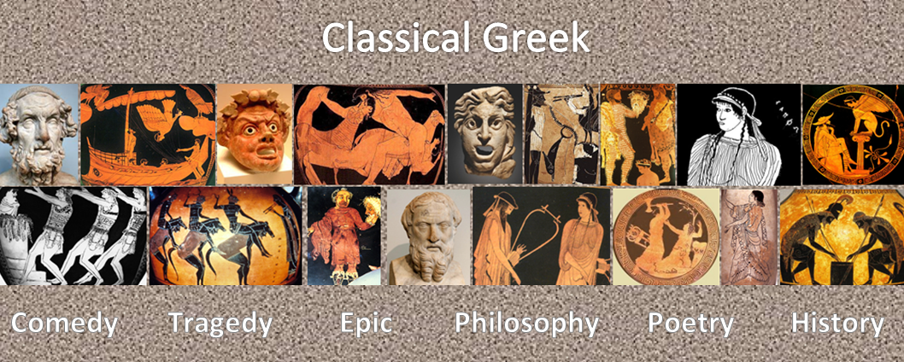

Why Classical Greek?

This really is something for you to decide! If you like what you have learnt so far and are still curious, then you may become one of a select group of people to study some of the oldest and best literature, philosophy and history in its original language. From the heroic poetry of Homer to the tragic playwrights like Sophocles or Euripides, you will find that most things that we value in our society derive from the Greeks. Studying ancient Greek is a window into what we are.

Why is it useful?

This is really only a language for those who have already found out that they have liked it! You have been studying Greek for the last two years only because you have found it interesting, and are finding that you are already good at languages. If you decide to carry on, a whole world of thought and experience opens up for you. People who have studied Greek often go on to work in universities or become classical archaeologists. Others opt for more normal routes and end up as bankers, or even teachers!

How am I assessed?

This course involves 6 lessons over 2 weeks studying both the language and two literature set texts.

Unit B401 –Greek Language 1 (written paper) 25%
Unit B402 –Greek Language 2 (written paper) 25%
Unit B403 –Greek Prose Literature (written paper) 25%
Unit B404 –Greek Verse Literature (written paper) 25%

When will I be assessed?

At the end of Upper V. There is no Controlled Assessment for Greek.

Which syllabus will I follow?

OCR

What other skills will I develop?

Logic, persistence and the dawning realisation that Europeans all speak the same language

And then?

University study, the corporate world, politics and media.

Computing

Through this qualification students can:

- Develop their understanding of current and emerging technologies and how they work
- Look at the use of algorithms in computer programs
- Develop computer programs to solve problems
- Acquire and apply creative and technical skills, knowledge and understanding of IT in a range of contexts
- Evaluate the effectiveness of computer programs/solutions and the impact of computer technology in society
Unit title and description | Assessment and duration | Weighting
Unit A451: Computer systems and programming
This unit covers the body of knowledge about computer systems on which the examination will be based. | 1 hour 30 minutes Written paper  80 marks | 40%
Unit A452: Practical investigation
An investigative computing task, chosen from a list provided by OCR, which assesses the following: research, technical understanding, analysis of problems, historical perspective, use of technical writing skills, recommendations/evaluation. | Controlled assessment  Investigative task. OCR-set scenario with a choice of research tasks. 45 marks | 30%
Unit A453: Programming project
Students will need to:  - Understand standard programming techniques  - Be able to design a coded solution to a problem including the ability to:  - Develop suitable algorithms  - Design suitable input and output format  - Identify suitable variables and structures  - Identify test procedures.  - Create a coded solution fully annotating the developed code to explain its function  - Test their solution:  - To show functionality  - To show how it matches the design criteria  - Identifying successes and any limitations. | Controlled assessment Programming task. Design, develop and test a solution to a problem within the OCR-set scenario.  45 marks | 30%

Please be aware that only students who have demonstrated strong maths skills will be recommended for this qualification due to the nature of the course.

Drama
Why Drama?
Drama provides a curriculum to ignite and engage students’ creativity, passion and interests. It also provides freedom for you to experiment and take risks with your work.
Encourages mental versatility – It provides opportunities to examine drama and the work of others, and to explore it as a practical art form.
Keeps the subject meaningful – It allows you to study drama in an academic setting, interrogating this art form and applying your knowledge and understanding to the process of creating and developing drama and to your own performance work.
A practical approach to assessment – There is a high percentage of practical assessment in the non-examined assessment and a single portfolio assessment.
Skills to help students stand out – The specification aims to create independent thinkers with skills in research, working with others, analysis, communication, time management, ICT, problem solving, planning and organising.
Why is it useful?
Drama is, and always has been, one of the most influential means of mass communication. It is a vital form of self-expression, which the world could not do without! Drama encourages empathy and deeper understanding of the world and the human condition.

How am I assessed?

1: Devising Drama – practical workshops and written portfolio and evaluation - 30%
2: Presenting and Performing Texts – externally assessed performance. Candidates develop two extracts from a text and can choose to perform or take on a performance support role, e.g. sound, costume - 30%
3: Drama: Performance and response – written examination – 40%

Which syllabus is it?

OCR GCSE (9-1) in Drama (J316)

What other skills will I develop?
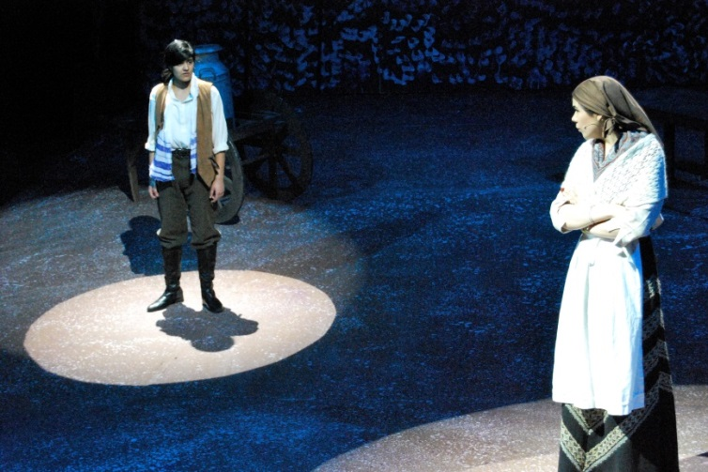
Drama encourages an in-depth interpretation of a variety of texts. Drama teaches you invaluable skills in presentation, communication and working within a team. Drama is also an excellent way to build self-confidence.

And then…?

The skills you will develop will prepare you for a career in a range of industries, from law to education, as well as theatre, film and television.

French

“In a globalised world, speaking only one language is no longer enough” (The Guardian)

“Being bilingual, it turns out, makes you smarter” (NY Times)

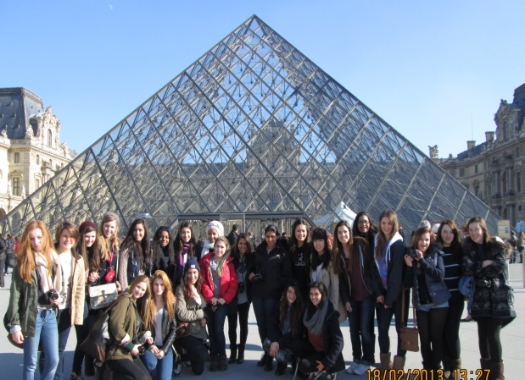
Why choose French?
- Communication – there are 338 million French speakers worldwide and this is expected to increase to 500 million by 2025.
- Travel - it is the official language of 29 countries.
- Culture – open your mind to the history, literature, film, poetry and art of other nations.
- University – considered by the Russell Group (UK’s leading 24 universities) to be one of ten ‘facilitating subjects’.
- Employability – competition in the world of work is fierce and speaking a foreign language is very appealing to employers.

French at St Augustine’s
- Passionate and academically rigorous teaching from native speakers.
- Visit abroad to the south of France and cultural excursions in London.
- Extra-curricular language clubs.
- Leadership opportunities at language events.

How am I assessed?
We currently follow the Edexcel International GCSE specification and, although many exams boards are changing their Modern Languages GCSE provision from September 2016, we may decide to continue with our current syllabus as it has proved popular, challenging and an excellent precursor to A Level learning. We will conduct a review during this academic year and we will let you know which route we decide to take as soon as the decision is made. Overleaf is an example from our current syllabus so that you can gauge the expectations at this level.

Paper | % of overall grade | Length of Exam
Paper 1  Listening | 25% | 5 minutes reading time  +  40-minute exam
Paper 2  Reading & Writing | 50%  (25% Reading)  (25% Writing) | 1 hour 30 minutes  (Includes 2 pieces of writing - 50 & 150 words)
Paper 3  Speaking | 25% | 10 minutes  Section A: Presentation (4 minutes)  Section B: 2 conversations (2 x 3 minutes)

A Level
French at A Level is taught by native speakers Miss Gandi and Ms Assemat. Students should have achieved a GCSE grade A or above in order to study the language at this level.

University and beyond
We have had students go on to study the language at university. After university people with language degrees go into all sorts of different professions:

Victoria Ferran, Social Media Co-ordinator
“Languages really helped me when applying for jobs. I think my degree shows multiple skills and that you can juggle many things. It keeps your options open.”

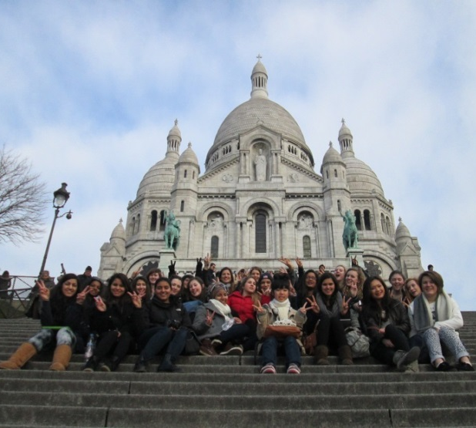

Geography

Why Geography?
In Geography you will learn about the world. Geography will help you make sense of the beautiful, complex and constantly changing environment we live in. You will learn how places and landscapes are made, how people and the environment interact and how the many and varied societies that inhabit the Earth are connected. It is about the past, present and future of our planet.

Why is it useful? When you learn Geography you not only learn about it but also all the other subjects it connects with, History, Chemistry and Biology to name but a few. You will master many important skills which you will use many years after you finish studying Geography, for example map reading, interpreting statistics, research techniques and compiling and presenting reports. Mastering the many skills required of a geographer will give you the confidence and independence to tackle university and become successful in your chosen career.
How am I assessed?
Living with the Physical Environment 35%
Challenges in the Human Environment 35%
Geographical Applications 30%

When will I be assessed?
The Geography GCSE is assessed at the end of Upper V.
All units will be assessed by written examinations.
There will be a need to complete two full days of fieldwork
(within the UK) in order to address both a human and a physical geography fieldwork question in the Geographical Applications exam.

Which syllabus is it?
AQA - syllabus number Geography 8035 (www.aqa.org.uk)

What other skills will I develop?
Geography will enhance your communication skills, develop your ability to work in a team, improve your ability to analyse and question, enhance your numeracy, literacy and computer skills as well as making you spatially, environmentally and socially aware.

And then…?

The skills you use in Geography make you of potential interest to a wide range of universities and employers. Statistics show that compared with other subjects, geographers are among the most employable. People who continue with Geography at university go into all sorts of different careers including: urban and town planning, local and national government, meteorology, education, human resources, environmentalism, research and tourism.

History
Why History?
You will study many of the fascinating world-changing events of the Twentieth Century but also from the Medieval and Early Modern periods and learn how to reach your own conclusions about the different areas of debate surrounding these events. You will also learn what Britain’s role in these events was. You will learn how to structure and develop an argument and how to analyse primary and secondary evidence critically.
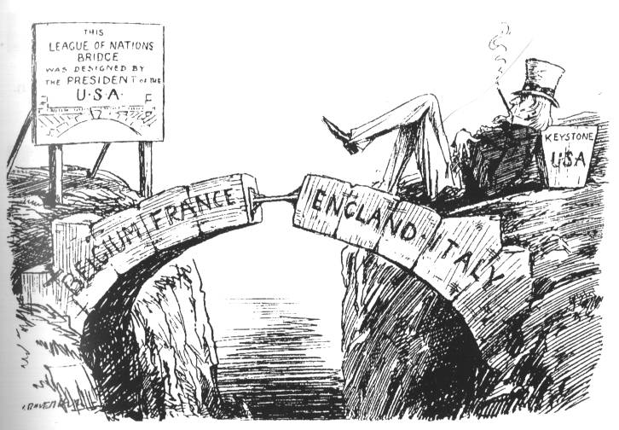

Why is it useful? The aim of the study of History is to develop students’ capacity for critical thinking and analysis. It will allow you to develop a curiosity about your own and other cultures, and provide you with an insight into the lives and experiences of ordinary people as well as those of leaders, monarchs and dictators. You will also develop an appreciation of how the past has influenced the world we live in today as well as its impact on your particular families.

How am I assessed?

Paper 1: Understanding the Modern World – Written exam: 1 hour 45 minutes: 50% of GCSE

Peacemaking 1918-1919 and the League of Nations
Hitler’s foreign policy and the origins of the Second World War
Russia: Tsardom and Communism 1894-1945

Paper 2: Shaping the Nation – Written exam: 1 hour 45 minutes: 50% of the total marks
Britain: Power and the People
British in Depth Studies including the Historical Environment

When will I be assessed?
You will sit Papers 1 and 2 in the summer of Upper V

Which syllabus is it?
AQA : History.
This is still subject to change following approval of the draft specification by Ofqual.

What other skills will I develop?
History is vital in allowing you to reach your own conclusions when confronted by information and views available to you in the media and news today. You will become more aware of bias, exaggeration and deliberate misinformation, and so question a particular writer’s or speaker’s motives rather than taking their views at face value.
It will also help you to develop arguments, debate different interpretations of events and opinions convincingly and dissect your opponents’ points of view.

And then…?

The aim of the study of History is to develop your capacity for critical thinking and analysis, which will be invaluable to you in most careers you wish to pursue and so will be a great asset to prospective employers in practically any profession, but particularly the fields of education, law, journalism, management and broadcasting.
Information Communication and Technology

We now live in a digital age; a GCSE in ICT will be useful in any career path!
Why Information Communication and Technology (ICT)?
You’ve been socialising on Twitter, Facebook, or MySpace. You have caught up with friends to watch YouTube and battled it out for first place on the Wii. Once again, you had to help your dad with downloading music and surprisingly even remembered to Wikipedia that info you need for school.

Why is it useful? ICT is not just about how you use technology and how it works, it is also about the effects it has on our daily lives, including everything from commerce and communication, to politics and the music industry.

How am I assessed?
There are two controlled assessments and two exams.

Unit 1: Understanding ICT 20%
This examination paper will test you on the functional elements of ICT. For example: Spreadsheets, Databases, online security, smart phones etc.

Unit 2: Solving Problems with ICT 30%
This controlled assessment consists of a portfolio of work which shows candidates’ attainment in obtaining and interpreting different types of information; using, developing and communicating information to meet the purpose of a scenario (which will be given in September). You will mainly use Microsoft Office for this.

Unit 3: ICT in Organisations 20%
This examination paper will assess the ‘application’ content of ICT in a business and industry context.

Unit 4: Developing Multimedia ICT Solutions 30%
This controlled assessment consists of using multimedia software to meet the purpose of a scenario. You will mainly be using the Adobe Creative Suite.

When will I be assessed?
All pieces of coursework will need to be completed before December 2016.
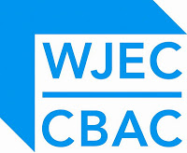
The examinations will be taken in September 2017.

Which Syllabus is it?
WJEC ICT GCSE: http://www.wjec.co.uk

Latin
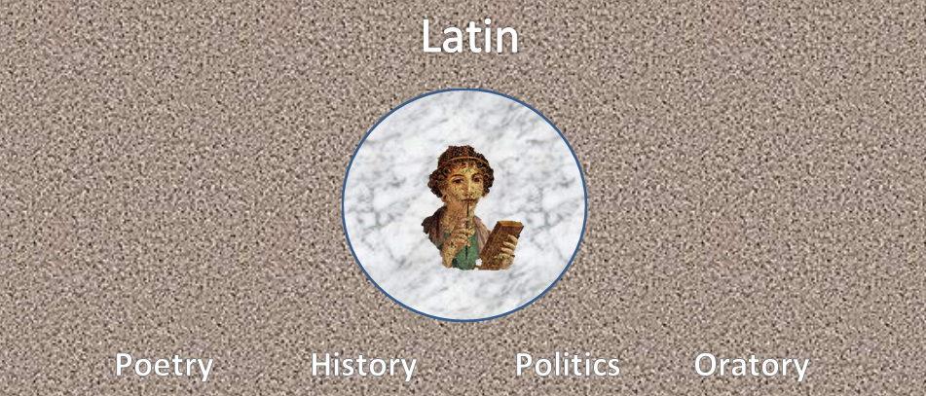
Why Latin?

This really is something for you to decide! If you like what you have done so far, are interested in the ancient world or in the study of languages in general, then Latin may be something for you. People get different things from studying old languages. Some people like to read writers in the original Latin, and want to experience for themselves the love of poems of Catullus or the sarcasm of Juvenal. Others are more interested in Latin itself and how it relates to most of our current European languages.

Why is it useful?

If you have not liked what you have done so far, or you find none of the above comments relevant, then studying Latin may not be for you. Latin GCSE may be a high status subject, be looked on favourably by universities, and be useful for many professions from law to medicine, but the GCSE course is not for the faint-hearted and should be undertaken by those people who think they will get something out of it.

How am I assessed?

This course involves 6 lessons over 2 weeks studying both the language and two literature set texts.

Unit A401 – Latin Language 1 25%
Unit A402 – Latin Language 2 25%
Unit A403 – Latin Prose Literature 25%
Unit A404 – Latin Verse Literature 25%

When will I be assessed?

At the end of Upper V. There is no controlled assessment for Latin.

Which Syllabus will I follow?

OCR

What other skills will I develop?

Almost unconsciously you will be developing your logical skills and powers of analysis. And, of course, you will get better at learning languages in general.

And then…?

At this stage few Arts subjects prepare you for a specific career. But, by developing intellectual rigour in your study of Latin, you will be well set to go into law, politics or the higher pursuit of higher learning.
Music
Important note. At the time of going to press, the new specifications for first teaching in 2016 are still in draft form. This page outlines the current course. The new course will take a broadly similar approach in the division between performing, composing and listening and appraising, but details will vary.
Why Music? Music GCSE is a unique option which combines practical work with the academic study of an exciting range of musical styles. You will develop a set of skills which will help you to become a well-rounded musician – not just performing, but composing, listening and understanding music.
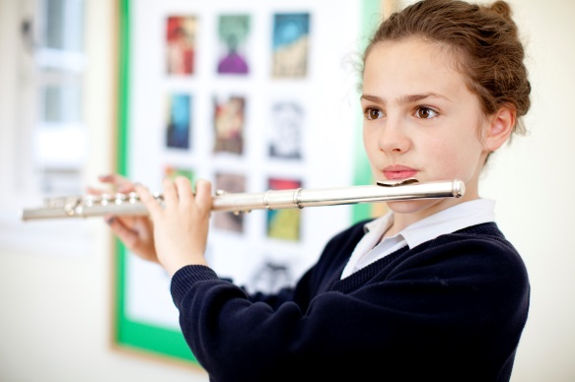
How am I taught? You will deepen your understanding of music by studying 12 set works, ranging from classical to jazz, rock, musical theatre and music from around the world. You will also be taught how to compose music in a range of styles, working independently but under close supervision, and using Sibelius software. It is expected that you will continue to have individual instrumental or singing lessons throughout the course, and that you should be involved in an extra-curricular music group to help develop your musicianship skills.

How am I assessed?
- Performing (30%): You will need to submit recordings of two performances, one solo and one as part of a small group or duet. To do well in this unit, you should submit pieces of about Grade 5 standard, so you should be at about Grade 4 when starting the course in Lower V, and committed to continuing instrumental or voice lessons throughout the course.
- Composing (30%): You will need to submit two compositions in contrasting styles. Almost any style is possible, whether classical, popular or inspired by music from around the world. Compositions are completed under controlled conditions during lesson time as far as possible.
- Listening and Appraising (40%): You will answer questions in an exam about the 12 set works, which will be very familiar to you through in-depth study over the course. Most of the questions are based on short excerpts which you listen to during the exam.

When will I be assessed?
Your progress in performing and composing will be monitored throughout the course, and your final Controlled Assessments will be completed by the end of Lent Term in Upper V.
Which syllabus is it?
Edexcel GCSE in Music (2MU01) (www.edexcel.com)
What other skills will I develop?
As well as being an enjoyable and worthwhile subject in its own right, studying Music can bring benefits to other areas of your life. For example, you will develop analytical and critical skills which can be transferred to other disciplines. Your confidence will grow through performing, and your ability to work and make decisions independently will develop through composing.
And then…?
You can continue your studies in the Sixth Form with Music A Level, which is highly regarded by top universities as an academic subject which can be included in offers for many subjects. Beyond that, there is a range of career options for which Music is a desirable qualification – performer, composer, recording engineer, producer, to name a few. But whatever your eventual career path, you will have gained a deeper appreciation of music which will enrich the rest of your life.
Physical Education
Are you ...
- passionate about sport?
- driven to find out how you can improve your performance?
- interested in how our bodies push themselves to their physical peak?
- keen to understand what influences participation in sport?
- intrigued by why nearly one billion people would watch a single sporting event?
If the answer is yes, then Physical Education is the subject for you. The course is extremely diverse, it allows you to explore and enhance your own sporting ability, but also bridges the academic divide between the arts and sciences.
What does the course consist of?
The course follows the Edexcel Syllabus and is focused on relating theory to sport and its impact on performance. 40% of the course is assessed through practical ability and 60% through the theory units below. 60% Theoretical Knowledge is assessed through 2 written examinations, and 40% through practical examination.
Component 1: 25%
- Applied Anatomy and Physiology
- Movement Analysis
- Physical Training

Component 2: 20%
- Health, Fitness and Well-being
- Sport Psychology
- Socio-Cultural Influences in Sport

Component 3: 40%
- Practical Performance. Performance is assessed in 3 practical activities. One must be an individual activity and one a team activity.

Component 4: 15%
- Undertaking of a Personal Exercise Programme – developing and evaluating your performance.

Whom does the subject suit?
PE suits students who have a passion for sport; students who will enjoy a fast paced and diverse course that covers many subject areas – yet is always underpinned by the student's application to sport. Students that have taken PE have combined it with a wide array of other subjects from Art through to Physics. Some are keen to study the subject further at university, whilst many take the subject because they realise it is important to study something you enjoy.
What might the subject lead onto?
The obvious suggestion is to say that it will lead onto A Level Physical Education and one of many of the sports-related degree courses available. However, the real benefit of the PE GCSE is that it enables you to develop a wide range of skills, as well as develop confidence and understanding in numerous practical disciplines. The same applies to the workplace. Sport is now such a huge industry that there are endless employment opportunities. A few examples are coaching, teaching, biomechanics, physiotherapy, sports rehabilitation, officiating, sports technology development, sports administration, sports management and media.
Russian

“In a globalised world, speaking only one language is no longer enough” (The Guardian)

“Being bilingual, it turns out, makes you smarter” (NY Times)

Why choose Russian?
- Communication - There are an estimated 260 million Russian speakers as a first or second language.
- Travel - it is the most widely spoken of the Slavonic languages and enjoys official status in 5 countries.
- Culture – open your mind to the history, literature, film, poetry and art of other nations.
- University – considered by the Russell Group (UK’s leading 24 universities) to be one of ten ‘facilitating subjects’.
- Employability – competition in the world of work is fierce and speaking a foreign language is very appealing to employers.

Russian at St Augustine’s
- Passionate and academically rigorous teaching.
- Cultural excursions in London.
- Extra-curricular language clubs.
- Leadership opportunities at language events.

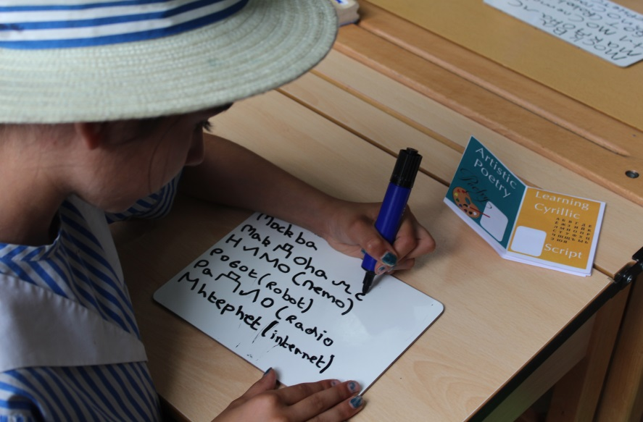

How am I assessed?
The new Russian GCSE specification will not be introduced until September 2017 and therefore you will continue with the current syllabus which is through Edexcel.

Paper | % of overall grade | Length of Exam
Unit 1  Listening and Understanding | 23% | 5 minutes reading time  &  45-minute exam
Unit 2  Speaking | 27% | 8-10 minutes
Unit 3  Reading and Understanding | 23% | 55 minutes
Unit 4  Writing | 27% | 1 hour

A Level
Russian at A Level is taught by Ms Kloc. Students should have achieved a GCSE grade A or above in order to study the language at this level.

University and beyond
After university people with language degrees go into all sorts of different professions:

Oliver Stevenson, Future Leaders Development Programme, Barclays
“There's a bit of a misconception – you don't need maths or finance degrees to join this scheme (Barclays graduate course). Barclays are after bright, entrepreneurial graduates. We have people with English, social sciences backgrounds, and I'm from languages of course.”

Spanish
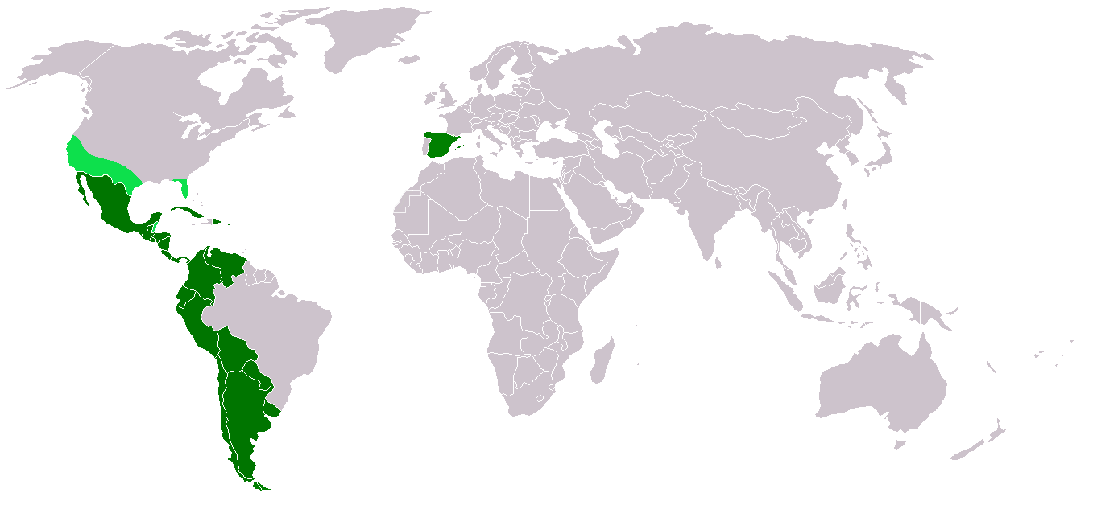
“In a globalised world, speaking only one language is no longer enough” (The Guardian)

“Being bilingual, it turns out, makes you smarter” (NY Times)

Why choose Spanish?
- Communication - there are an estimated 548 million Spanish speakers as a first or second language.
- Travel - it is the official language of 20 countries.
- Culture – open your mind to the history, literature, film, poetry and art of other nations.
- University – considered by the Russell Group (UK’s leading 24 universities) to be one of ten ‘facilitating subjects’.
- Employability – competition in the world of work is fierce and speaking a foreign language is very appealing to employers.

Spanish at St Augustine’s
- Passionate and academically rigorous teaching from native speakers.
- Visit abroad to Salamanca and cultural excursions in London.
- Extra-curricular language clubs.
- Leadership opportunities at language events.

How am I assessed?
We currently follow the Edexcel International GCSE specification and although many exams boards are changing their Modern Languages GCSE provision from September 2016, we may decide to continue with our current syllabus as it has proved popular, challenging and an excellent precursor to A Level learning. We will conduct a review during this academic year and we will let you know which route we decide to take as soon as the decision is made. Below is an example from our current syllabus so that you can gauge the expectations at this level.

Paper | % of overall grade | Length of Exam
Paper 1  Listening | 25% | 5 minutes reading time  +  40-minute exam
Paper 2  Reading & Writing | 50%  (25% Reading)  (25% Writing) | 1 hour 30 minutes  (Includes 2 pieces of writing - 50 & 150 words)
Paper 3  Speaking | 25% | 10 minutes  Section A: Presentation (4 minutes)  Section B: 2 conversations (2 x 3 minutes)

A Level
Spanish at A Level is taught by native speakers Mr Alejandro and Ms de Lahitte. Students should have achieved a GCSE grade A or above in order to study the language at this level.

University and beyond
We have had students go on to study the language at university. After university people with language degrees go into all sorts of different professions:

Oliver Stevenson, Future Leaders Development Programme, Barclays
“There's a bit of a misconception – you don't need maths or finance degrees to join this scheme (Barclays graduate course). Barclays are after bright, entrepreneurial graduates. We have people with English, social sciences backgrounds, and I'm from languages of course.”

And Then…?

The number of subjects you study after GCSE reduces which is why it is important to select a variety of subjects and aim to develop a wide range of skills when you decide on your options at GCSE.

 | Course | Study Outline
Lower V and Upper V | GCSE | - You will study about 10 subjects.  - This will include Religious Studies, English Language, English Literature, Mathematics, Science and other subjects you choose.  - There is controlled assessment in some subjects that counts towards your final exam grade.  - The main exams are all at the end of Upper V.
Lower VI | AS level | - You will now choose 3 or 4 subjects for A Level.  - For some subjects, you will sit the exams at the end of Lower VI.  - Some subjects may have coursework.
Upper VI | A level | - For subjects not taken at AS, you will continue them to A Level.  - You sit exams at the end of Upper VI.  - You apply to university.
University | Degree | - During your Upper VI year you apply to 5 universities using an on-line system called UCAS.  - The universities look at your GCSE and AS results, read what you have said about yourself on the application and take into account the School’s reference. They then offer you a place dependent on your A Level results.

Didn’t they do well…

Just to inspire you……….
Have a look at these Augustinian university destinations.
It will be your turn soon; it is just a question of making the right choices!

2015 University Destinations

Celine Alfalah | Law | Brighton University
Kajal Bal | Criminology/Law | Northampton University
Pavinder Bath | History/Politics | Birmingham University
Jessica Ball | Economics | Kent University
Sara Gulamali | Art | Central St Martins
Thedini Liyanage | Sociology | Brunel University
Sabrina Louisor | Art | Loughborough University
Alice Lyons | Politics | Manchester Met University
Nisna Mahtani | English | Coventry University
Rachel McGee | Politics/Philosophy | Liverpool University
Celine Moran | Politics | Oxford Brookes University
Clare O'Gorman | Politics | Nottingham University
Megan O'Flynn | Mathematics | City University
Sinead O'Sullivan | History/Politics | Sheffield University
Diana Petrosyan | Business Economics | Nottingham University
Sruthi Pirabakaran | Biomedicine | Plymouth University
Kiran Sandhu | Graphic Design | University of the Arts London
Maddie Swain | Psychology | Brighton University
Natasza Tytko | Politics and International Relations | Nottingham University
Yi Zhou | Economics | Warwick University

2014 University Destinations

Eleftheria Ananias | Management (2015 deferred entry) | Nottingham University
Helene Bergin | Art Foundation | Arts University Bournemouth
 | History of Art (2015 deferred entry) | Nottingham University
Kiran Brar | International Business & Economics | Aston University
Lillian Babayan | Geography | University College London
Tara Delargy | Geography | Leeds University
Hannah Gallagher | Drama | Kent University
Rebecca Graham | English Literature & Creative Writing | University of East Anglia
Saffron Green | Social Sciences | London School of Economics
Suzanna Harrison | Chemistry | Nottingham University
Katie Ingram | Environmental Sciences | University of East Anglia
Rachel Jones | Geography | Cardiff University
Hala Mansour | Business | Kingston University
Sophie Masih | Modern Languages | University College London
Zara Mirza | Political Science and Philosophy | Birmingham University
Hannah Moores | Politics with International Relations | York University
Ciara Moore | Art Foundation | Leeds College of Art
Sacha Page | Art Foundation | Arts University Bournemouth
Ranmini Philomin | Biomedicine | Aston University
April Rassam | Medicine | St George’s, University of London
Helena Routledge | Engineering (Deferred entry 2015) | Bath University
Natasha Rushton | Management | Manchester University
Eugenie Serkilar | Biochemistry | Kingston University
Ellen Welsh | Social Policy | Bristol University

My Notes

St Augustine’s Priory
Hillcrest Road, Ealing, W5 2JL
Tel: 020 8997 2022

admissions@saintaugustinespriory.org
www.sapriory.com

